Tạo và chạy nmap script sau đây:  
----------------------------------------------------

local http=require 'http'

description = [[ This is my custom discovery on the network ]]

categories = {"safe","discovery"}

require("http")

function portrule(host, port)

return port.number == 80

end

function action(host, port)

local response

response = http.get(host, port, "/config.php")

if response.status and response.status ~= 404

then

return "successful"

end

end

--------------------------------------------------------------



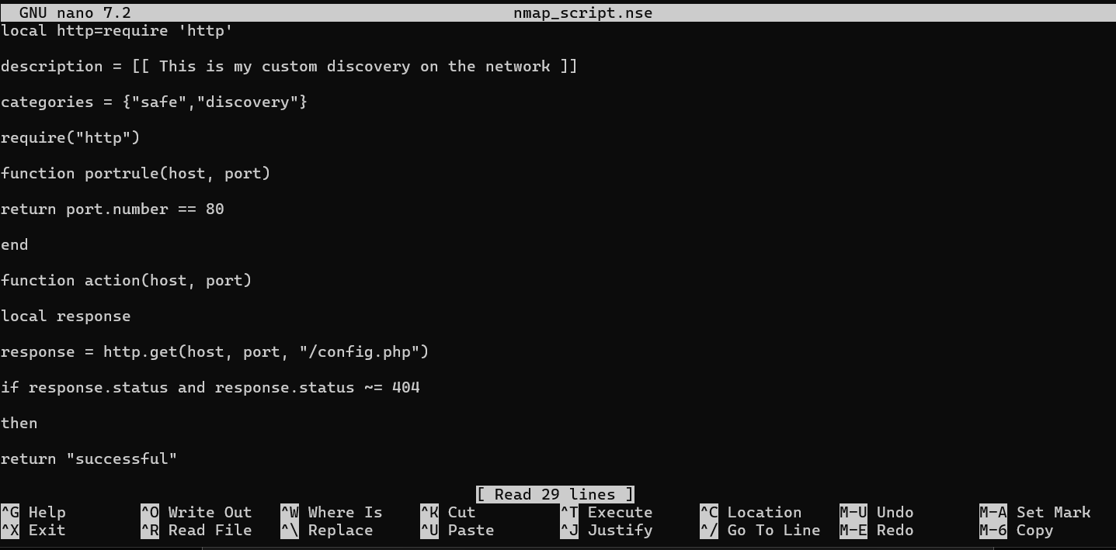

nmap -p 80 --script ./nmap_script.nse 192.168.1.1

nmap -p 80 --script ./nmap_script.nse 192.168.1.0/24

nmap -p 80 --script ./nmap_script.nse -T4 192.168.1.1

nmap -p 21-25 --script ./nmap_script.nse 192.168.1.0/24

